Nama : Hardiansyah Firdaus

NIM : 1207070052

Latihan 1 = Transformasi Twirl

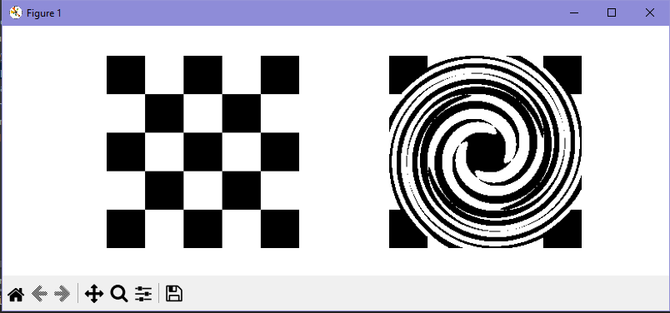

Latihan 2 = Translation

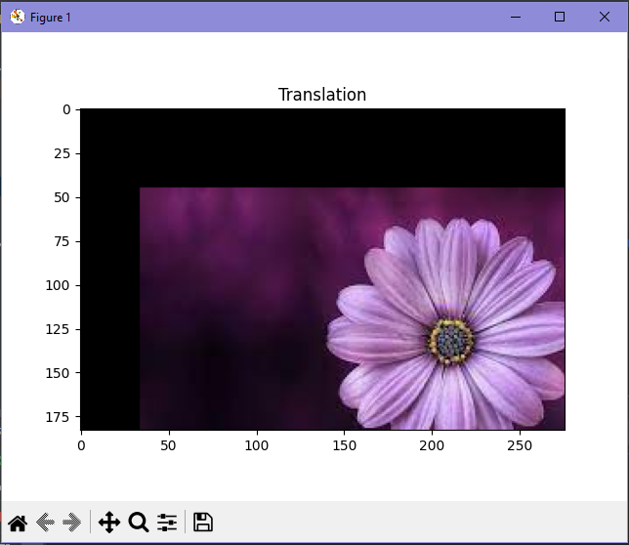

Latihan 3 = Rotation

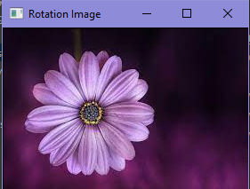

Latihan 4 = Interpolation

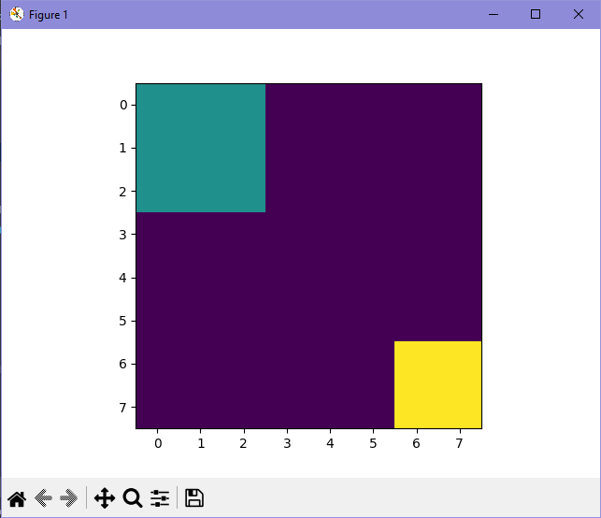

Background size 51

Size of first region:9

Sum of first region:3.730837450034167

Latihan 5 = Skala Interpolasi Miring

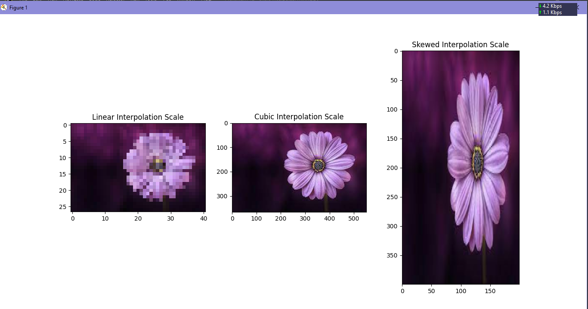

Link Github

<https://github.com/hrdz13/Perkuliahan/tree/e6687ebcc8c62b989ebc51f63f07298137ae4014/1207070052_Hardiansyah%20Firdaus/Praktikum%2012>